

|  |  |  |  |  |  |  |  |  |
| --- | --- | --- | --- | --- | --- | --- | --- | --- |
|  | | | | | | | | |
|  | | Database Final Project“E-commerce Store” | | | | |  | |
|  |  | | | | | | |  |
|  | | | |  |  | | | |
|  | | | | Zeyad Ahmed Samer Saeed Eldamarawy |  | | | |
|  | | | | Date31/12/2022Course titleDatabase SystemsDr.Salah Elewa |  | | | |
|  | | |  | | |  | | |



|  |  |  |  |  |  |  |  |  |
| --- | --- | --- | --- | --- | --- | --- | --- | --- |
|  |  | | |  |  | | |  |
|  | Project Description | | | | | | |  |
|  |  | | |  |  | | |  |
|  |  | |  | | |  | |  |
|  |  |  | This project is a full-stack E-commerce Store application. The user of this is project is able to sign up and sign in, view products, add products to cart and submit orders | | |  |  |  |
|  | | | | |
|  |  |  |  |
|  |  |



|  |  |  |  |  |  |  |
| --- | --- | --- | --- | --- | --- | --- |
|  | |  |  |  |  | |
|  | | Application Dependencies | | |  | |
|  | |  |  |  |  | |
|  | Technologies used in that project:  * **Frontend:** Angular framework that uses the JavaScript language * **Backend:** Node.js using express framework * **Database:** PostgreSQL database * **Database running environment:** The database is created and manipulated using Docker which creates a container(running environment) for PostgreSQL image (app). * **Migration:** db-migrate library is used in order to run all the SQL files necessary for creation of the tables in certain order in addition to droping tables. | | | | |  |
|  |
|  | |  |  |  |  | |
|  |  | | | | |  |

|  |  |  |  |  |  |  |
| --- | --- | --- | --- | --- | --- | --- |
|  | |  |  |  |  | |
|  | | Running the Backend | | |  | |
|  | |  |  |  |  | |
|  | Navigate to the storefrontapi directory using command  “cd storefrontapi”Run the docker compose file(which have set of commands and configurations necessary for creating the PostgreSQL running environment and database connections) using the command “docker compose up”Execute the postgres terminal using to interact with PostgreSQL database using the following command “docker exec -it <image-name> /bin/bash” . Note that <image-name> is storefrontapi-postgres-1. To check that the container is running run on your terminal “docker ps” to see running containers.Navigate to postgres using the following commands.Su postgres  * psql * Create database store * \c store * Then you can run any queries * Then navigate to storefrontapi directory and run npm run watch | | | | |
|  | |  |  |  |  | |
|  | | Running the Frontend | | |  | |
|  | |  |  |  |  | |
|  | Navigate to the Mystore-app/app directory using“cd Mystore-app/app”Then run “ng serve -o” | | | | |

# ERD Diagram

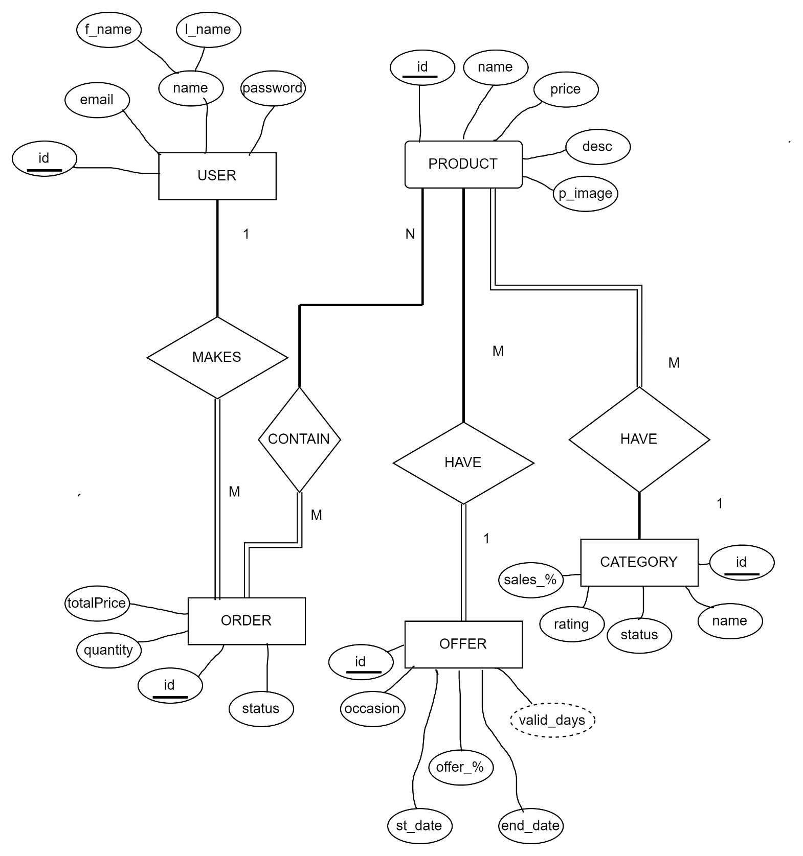

# Project Flow

##### Sign up and Sign in:

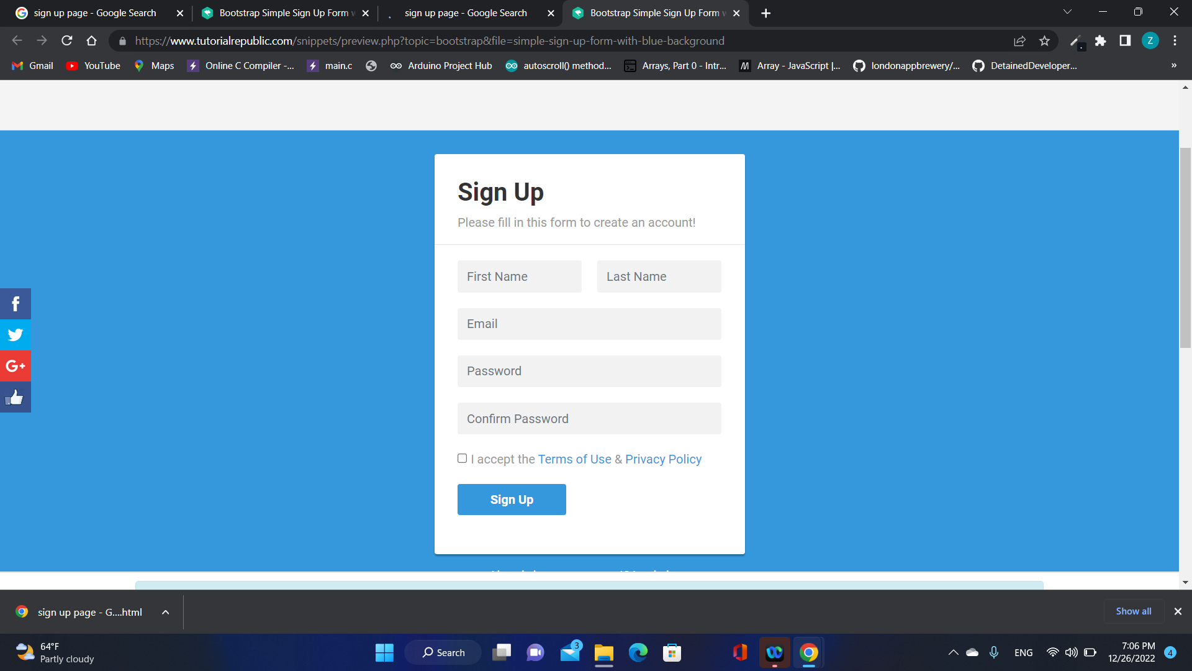

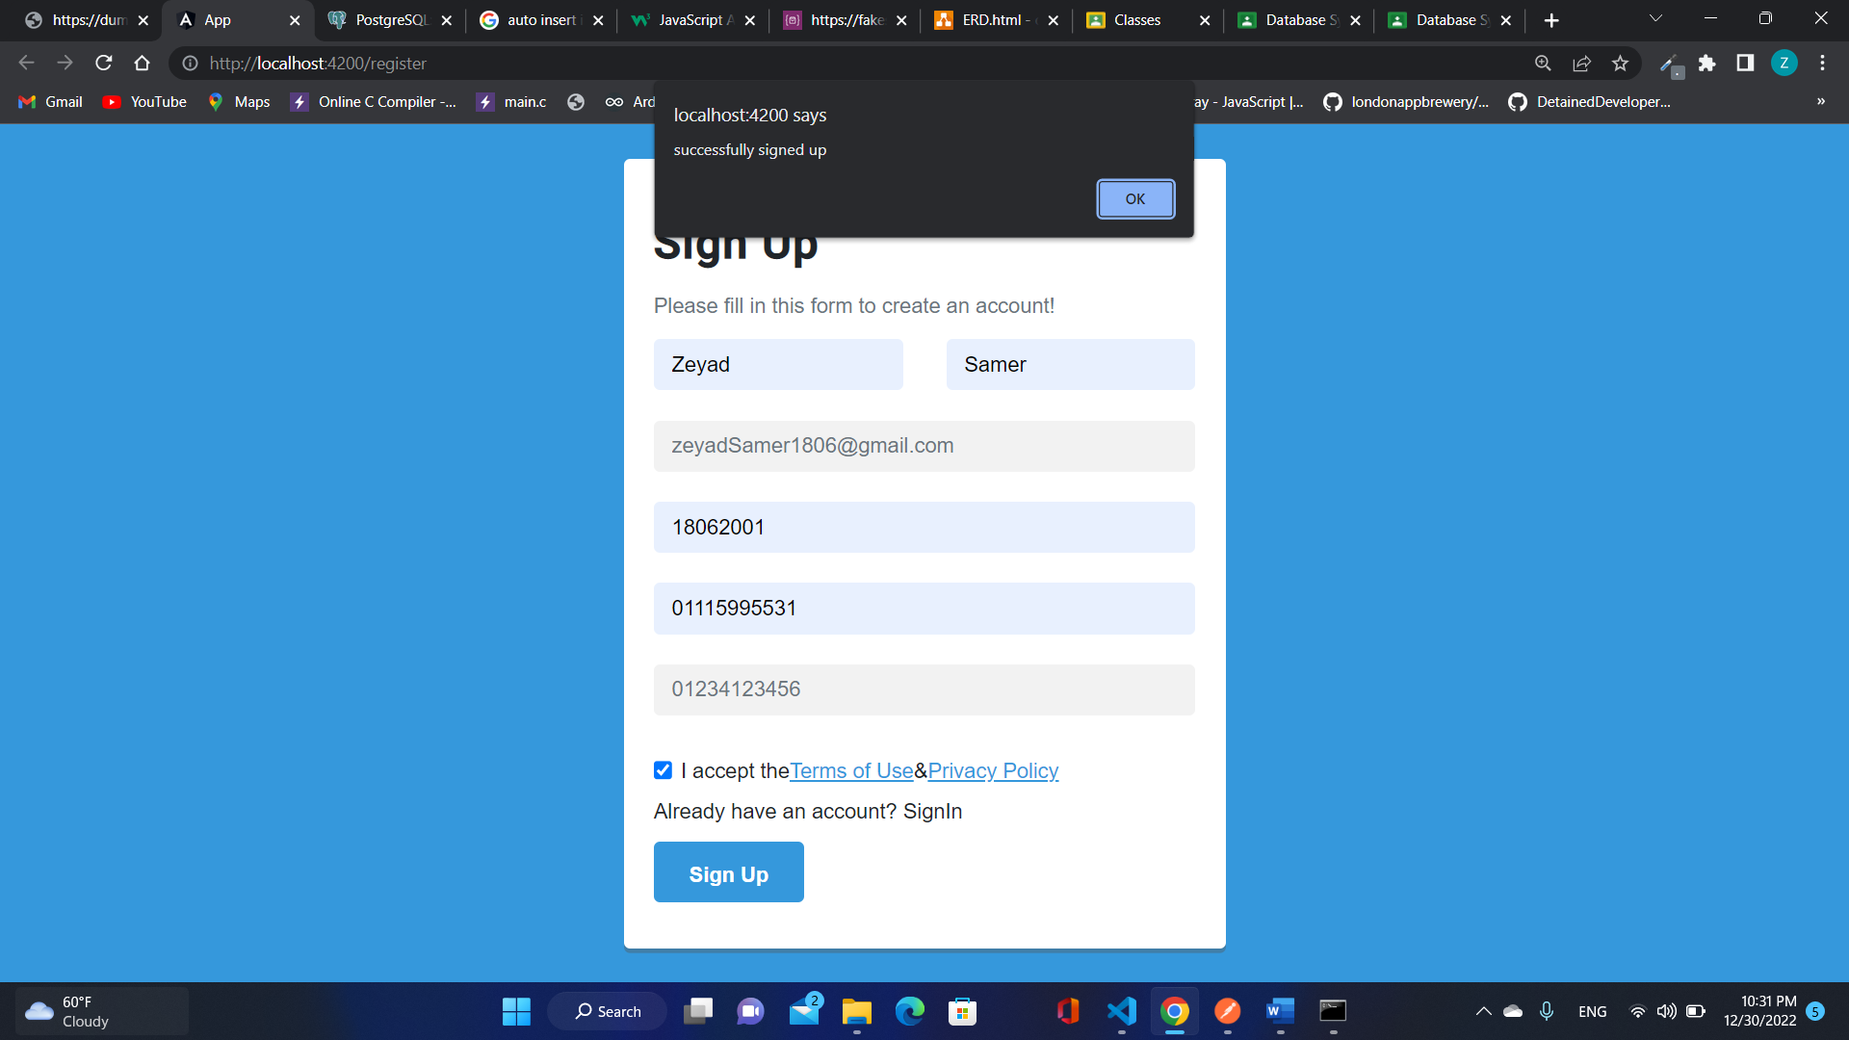

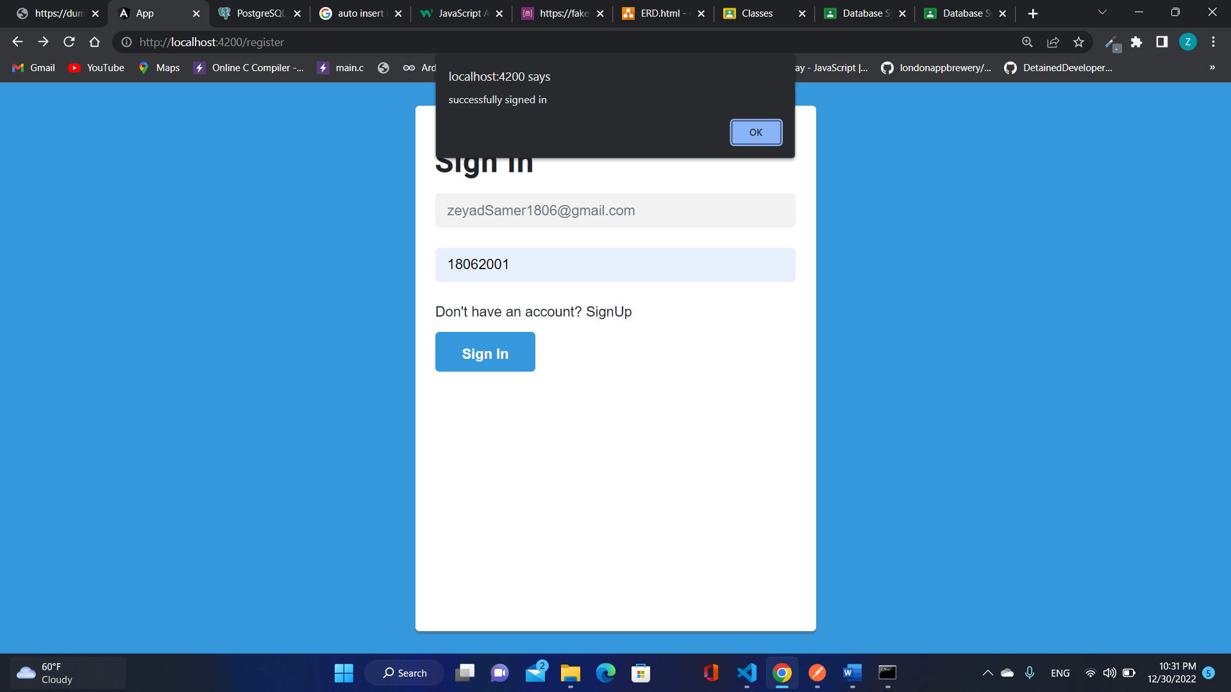

##### Application :

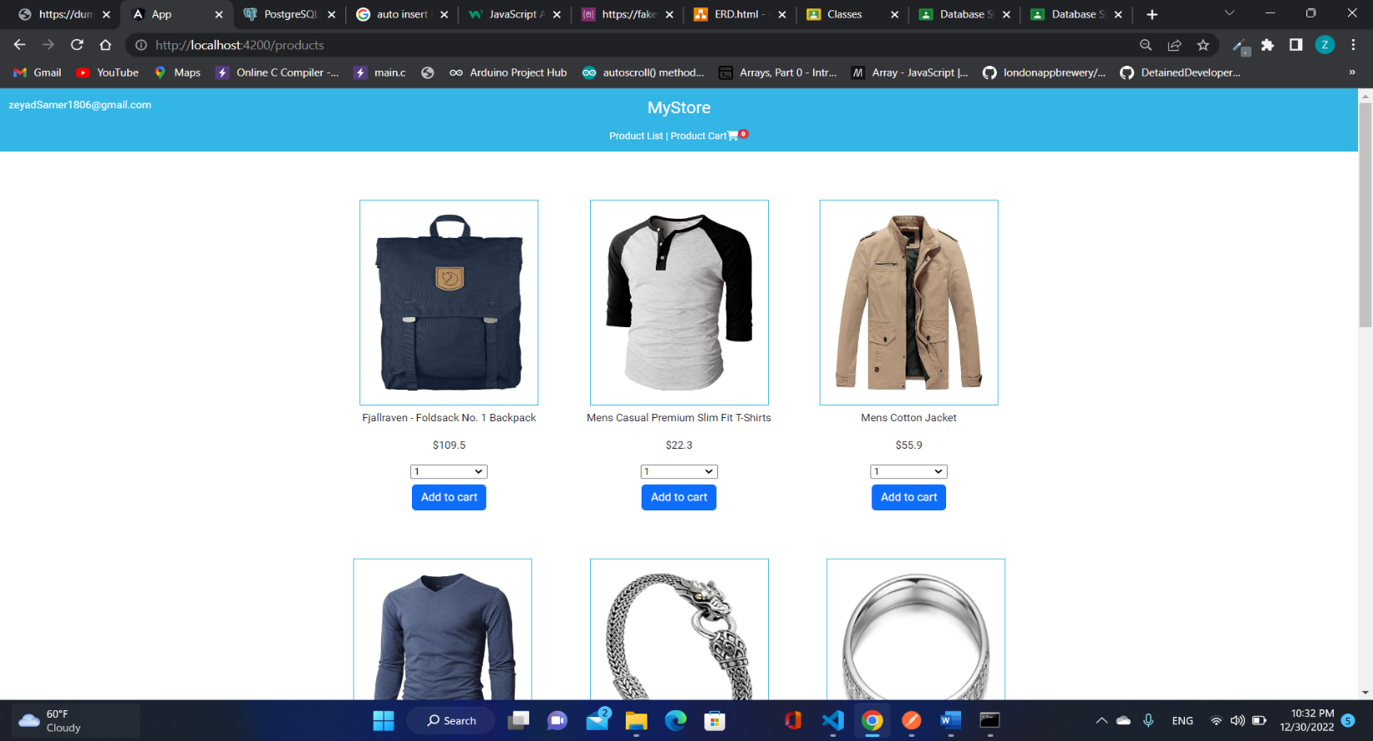

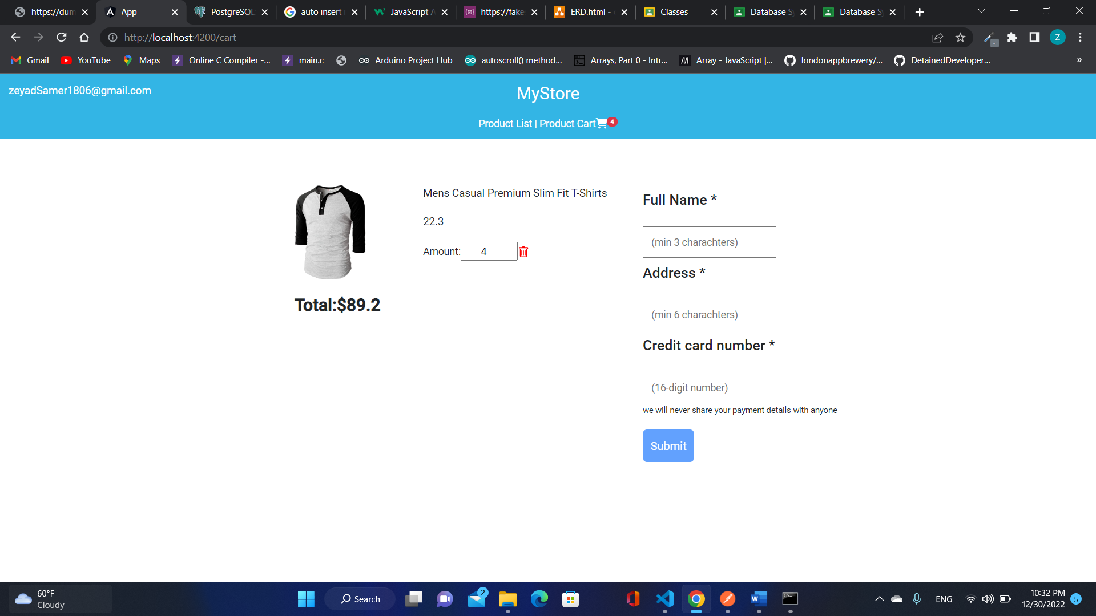

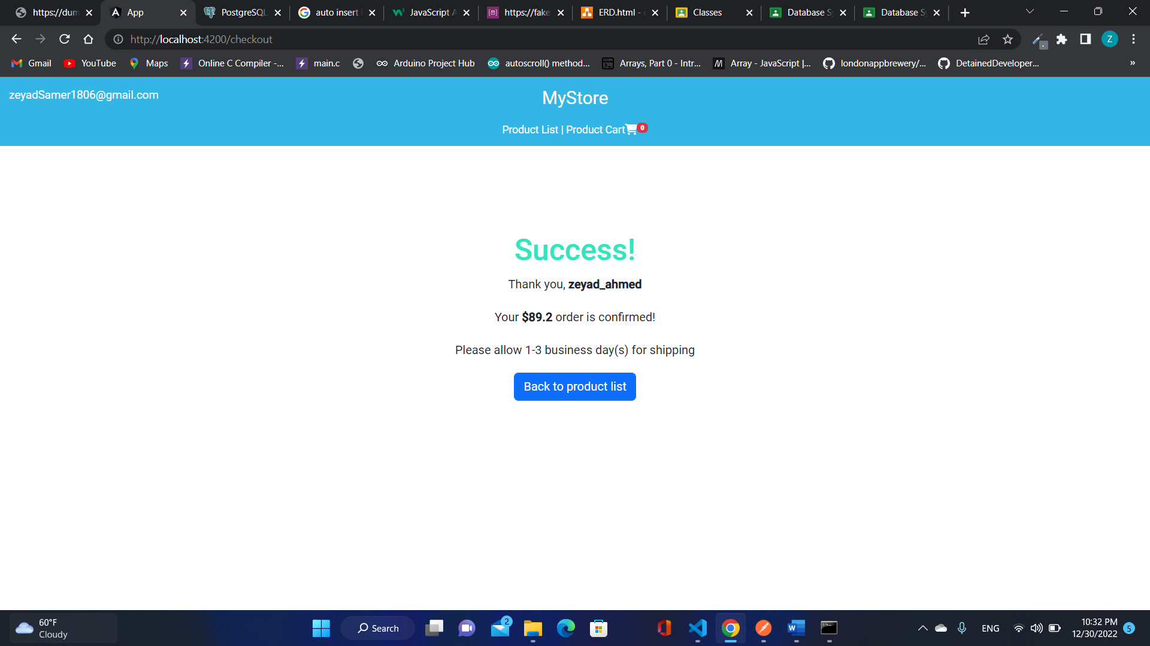

##### SQL Queries and Tables

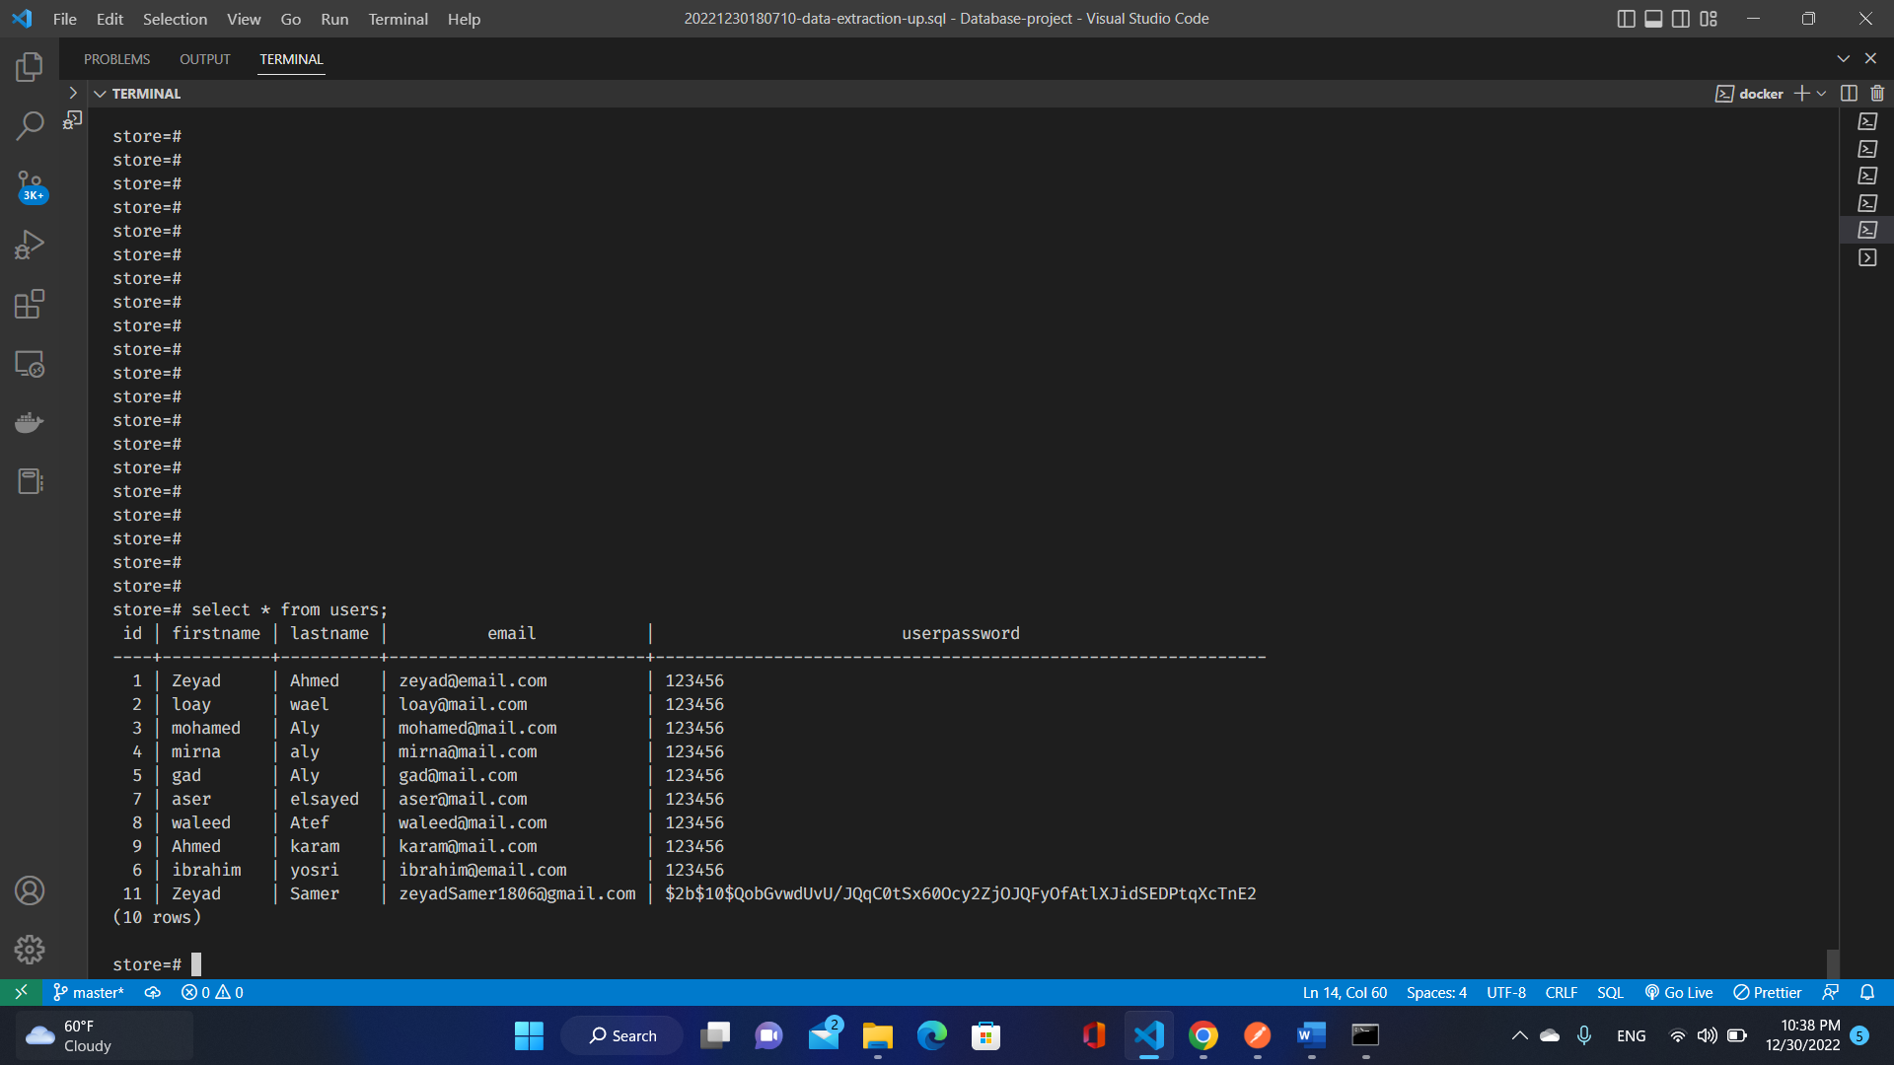

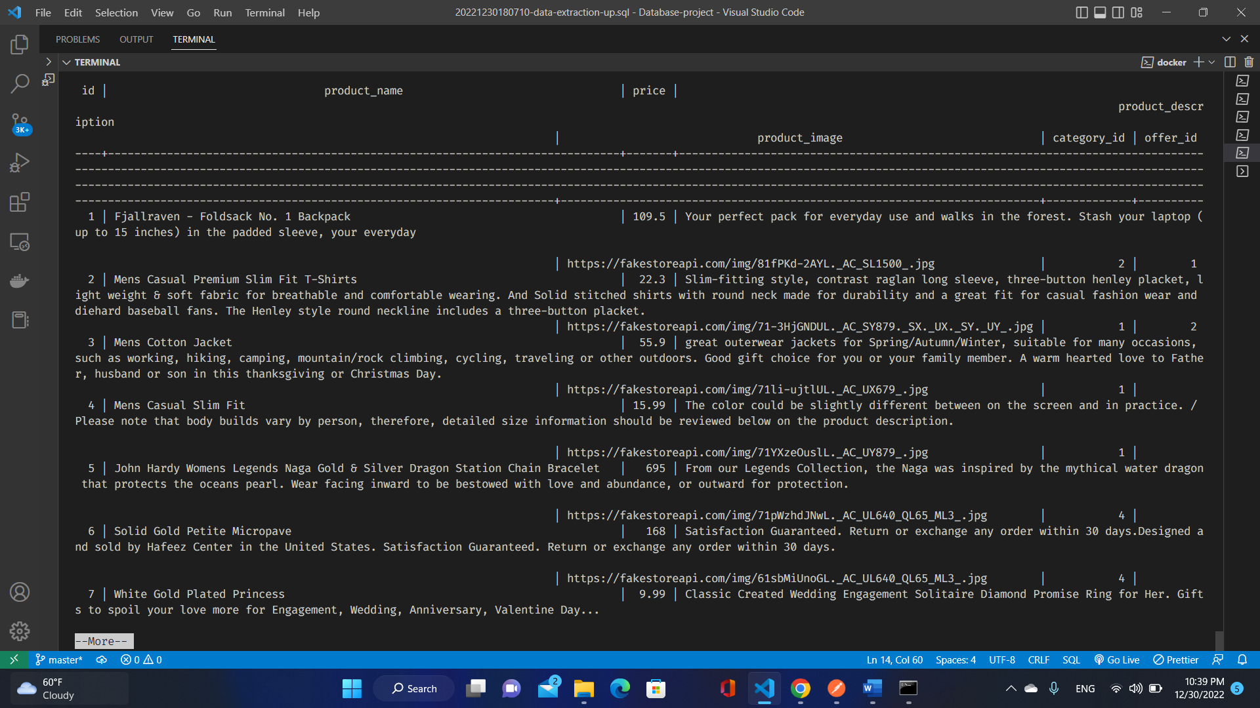

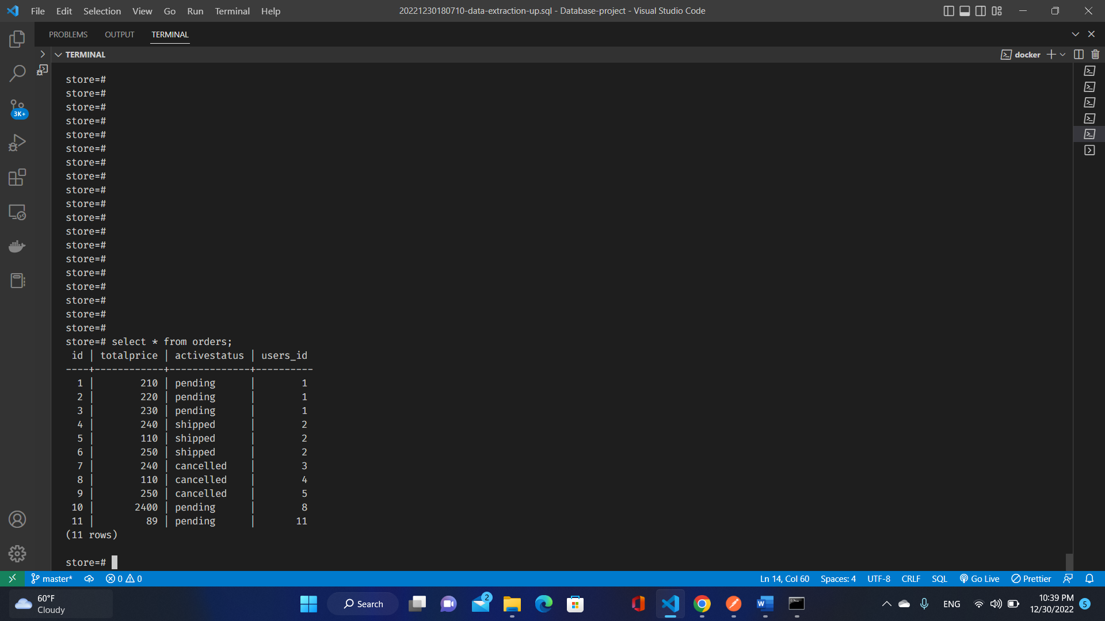

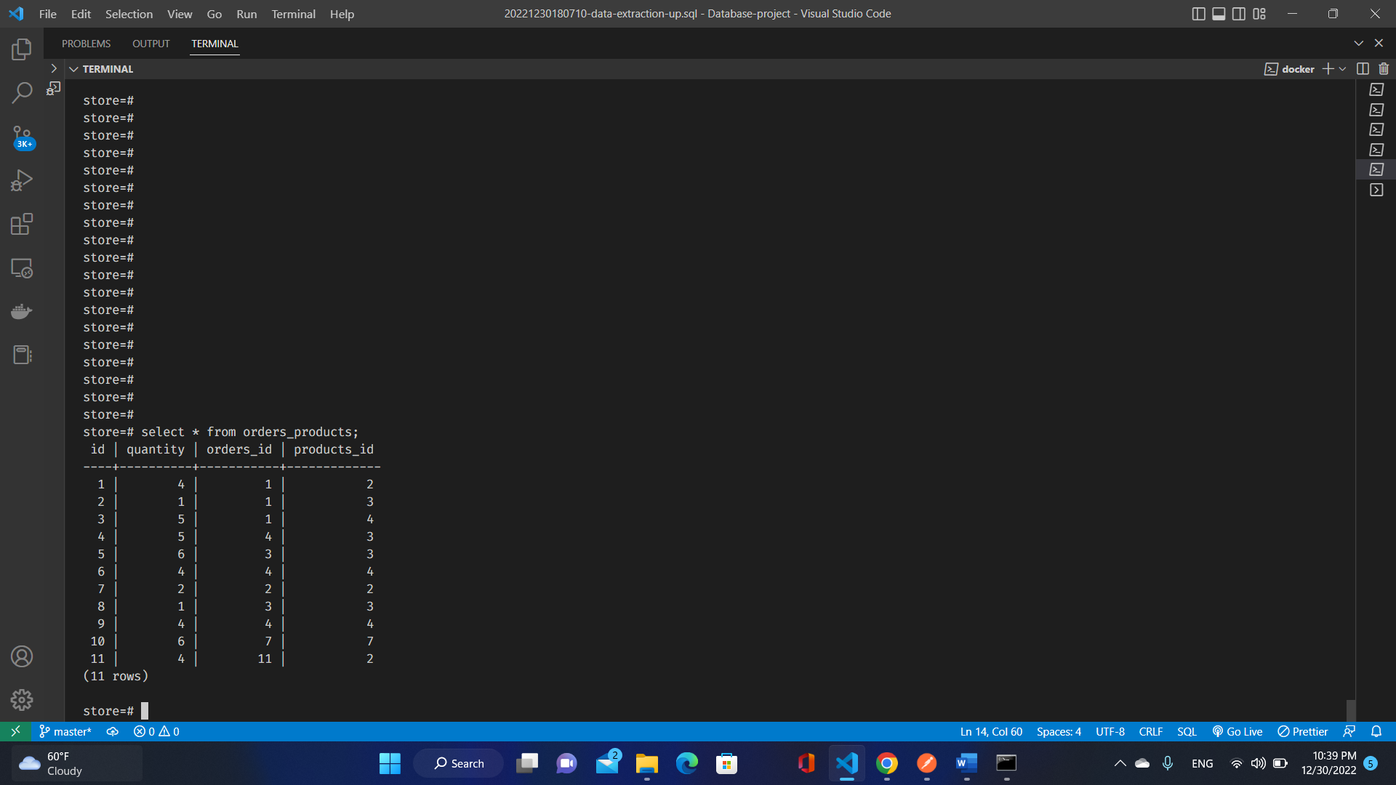

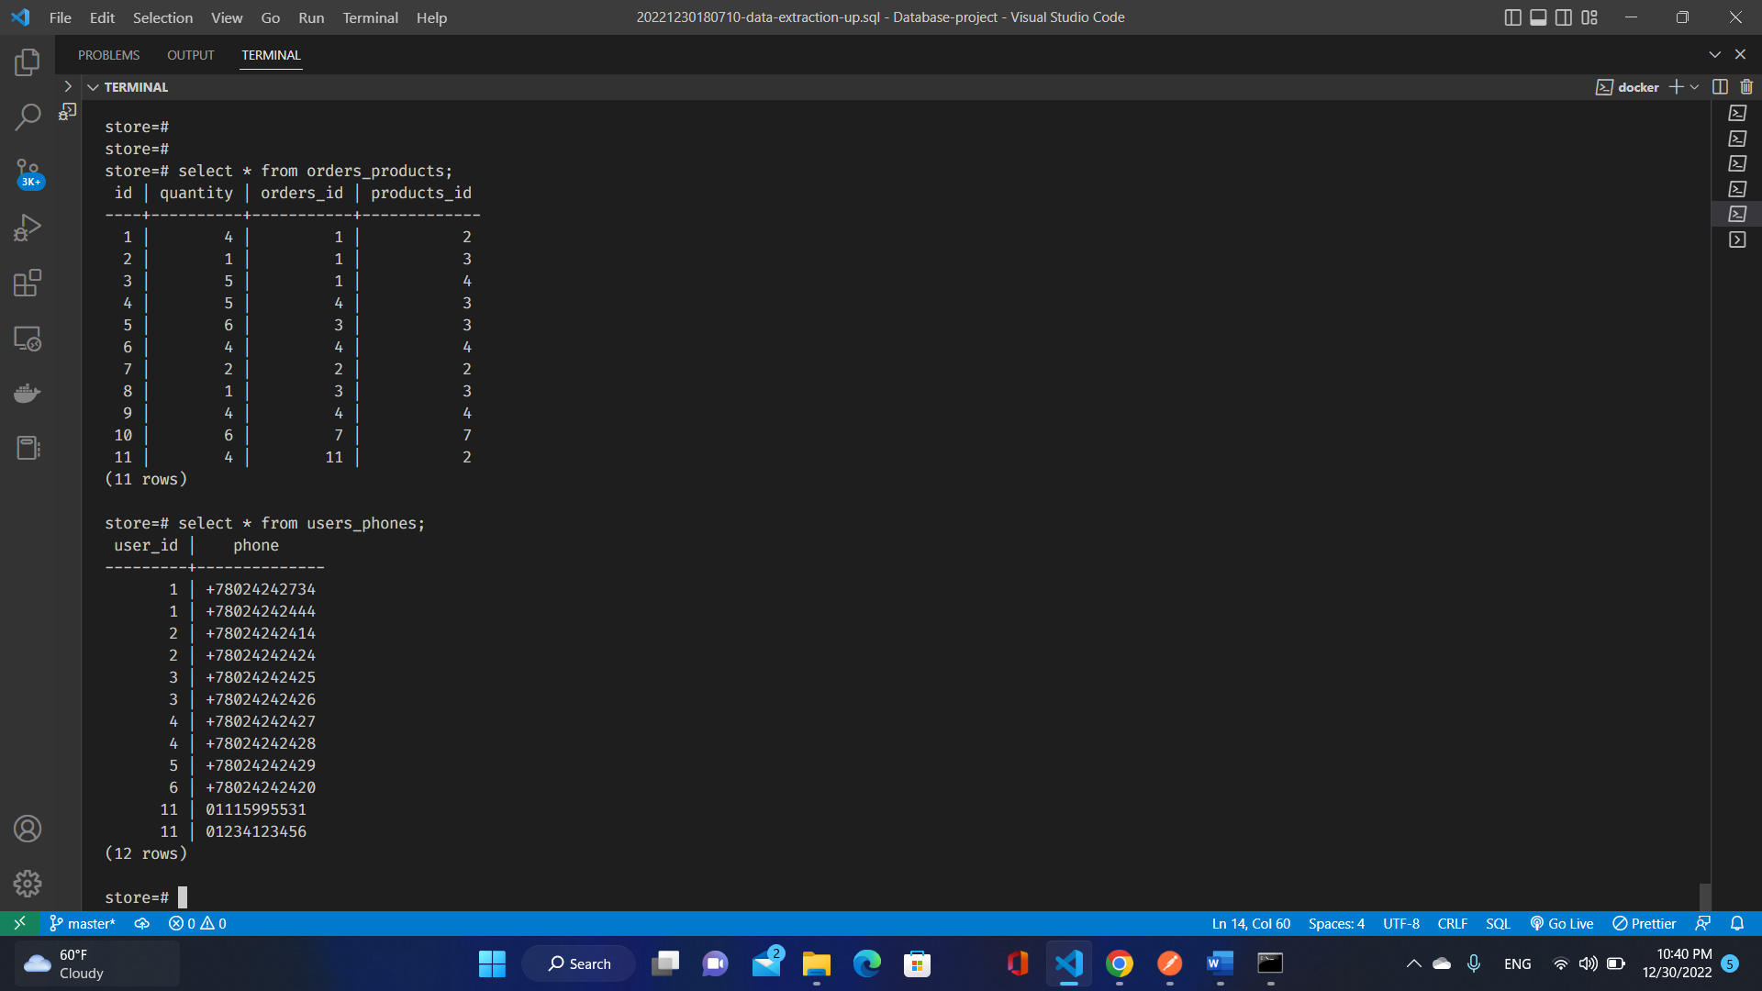

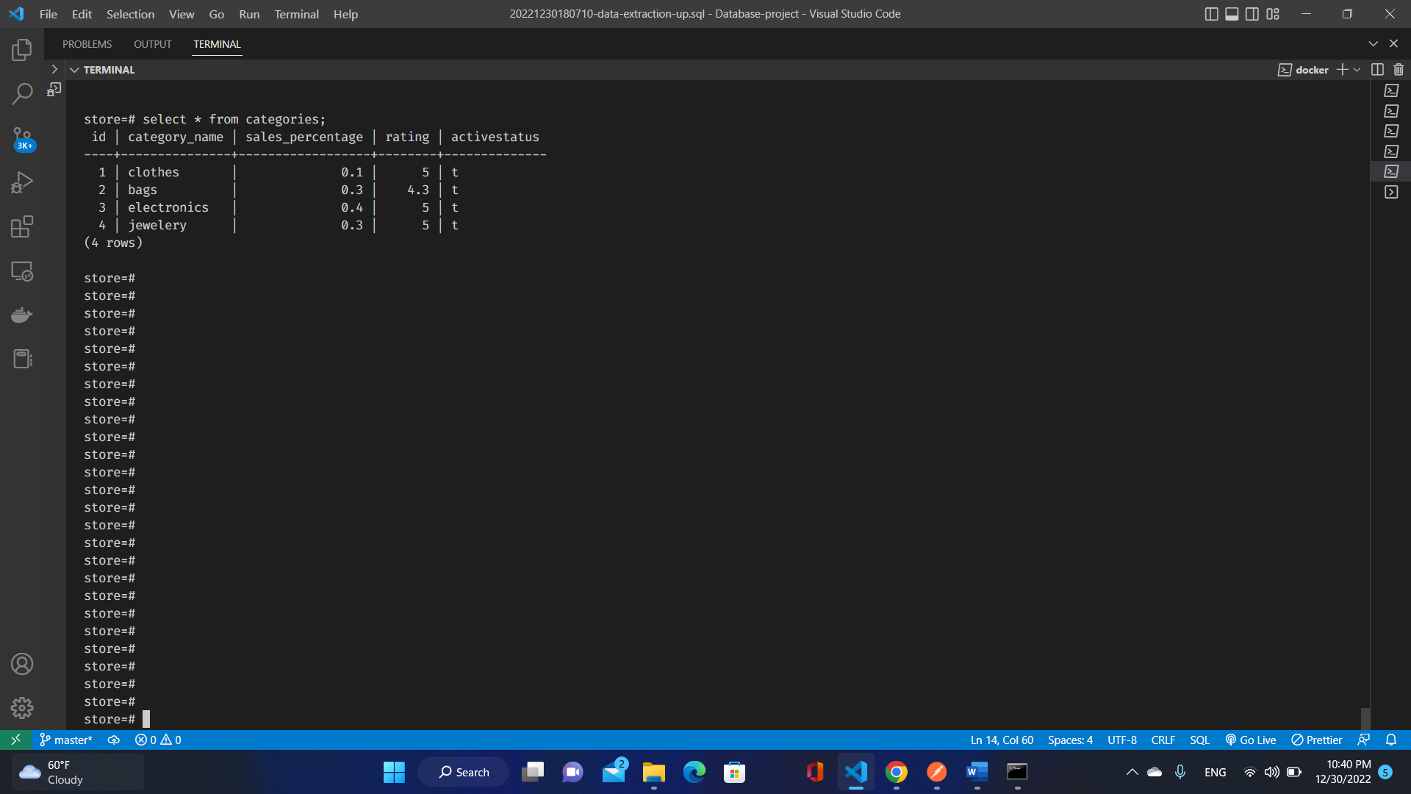

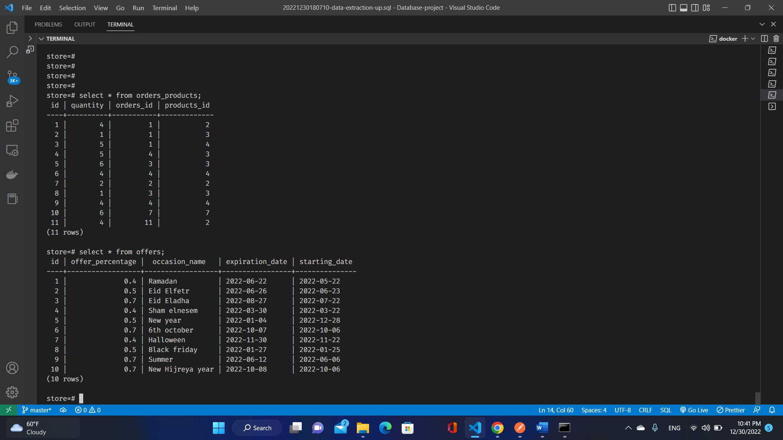

##### Sql Queries for data extraction and manipulation

SELECT * FROM USERS;

DELETE from users where id=10;

UPDATE  users set email='ibrahim@email.com' where email='ibra@mail.com';

SELECT max(price)as Maximum_Product_Price from products;

SELECT avg(price)as avg_Price_for_store_products from products;

select * from users join users_phones on users.id=users_phones.user_id;

 select product_name,price as old_price,price *offer_percentage as new_price,offer_percentage,occasion_name,

  expiration_date  ,starting_date ,(expiration_date - starting_date) as remaining_days

  from products join offers on products.offer_id=offers.id;

##### Results:

